***Target Audience: Internal Team/Investors who have reason to know and understand exactly what we’re building, how, and why. The intended style is precise enough for devs to know exactly what to do, yet remarkably concise so average folks can understand everything quickly.***

UncensoredGreats WhitePaper

The Internet has come to rely almost exclusively on Big Tech services as its information aggregators. This works well for current events, but leaves behind the content-rich information of the past. 95-99% of webpages, or the ‘deep web’, is inaccessible to search engines. As a result, everything that isn’t (1) search-engine optimized, (2) open-access, or (3) brand new, is lost to the everyday user.

Search engines have become the place for quick answers, forcing sites optimized for clicks into being shallow and uniform. Social, blogging, video sharing, and podcasting platforms offer tremendous depth and variety, but you can’t ever find anything. This is by design.

Since content platforms own the data they host, content richness and engagement are prioritized over searchability. Since aggregators do not own the data they point to, searchability is optimized for the clicks with minimal engagement. This conundrum should feel awfully familiar to any daily Internet user.

Search engines can’t benefit from content they point to because they don’t own it. Platforms can’t use the content of other platforms because they don’t own it. UncensoredGreats lets people put searchability and engagement under the same roof for any Internet content they wish to port because data ownership at every level falls to individuals.

UncensoredGreats is a distributed network in cypherspace where ‘code is law’, not just for money as with Bitcoin, but for generic data types: Text, video, and audio inside ebooks. Here, the content aggregator, host, and owner are one and the same, reporting only to a community of peers for governance.

### Structure

Blockchain technologies are borderless by default. This is obvious geographically, but it also applies to the other imaginary lines we draw between the categories we work in. Since UncensoredGreats is P2P network powered by an infinitely scalable protocol, it best reflects a pan-industry platform of the Web’s core elements.

As such, this whitepaper is broken down by section, each describing the architecture and user experience for our Web3 equivalent of each Web2 Building Block:

* Search Engine (Home)
* E-Reader (Read)
* Storage (Drive)
* RevShare (Earn)
* NFT-Marketplace (Trade)
* Search Manager (Aggregate)
* AI/LLMs (Create)
* Social Media (Share)
* Publisher (Internet of Books)
* DeFI Suite (Tokenomics)
* DAO (Governance)

### Home

New users are greeted with a homepage, inclining them to interact with domain-specific search engines.

These search engines are curated and owned by other contributors we call *Librarians*. Each is a curated set of books with real-time full-text-search on their aggregate contents.

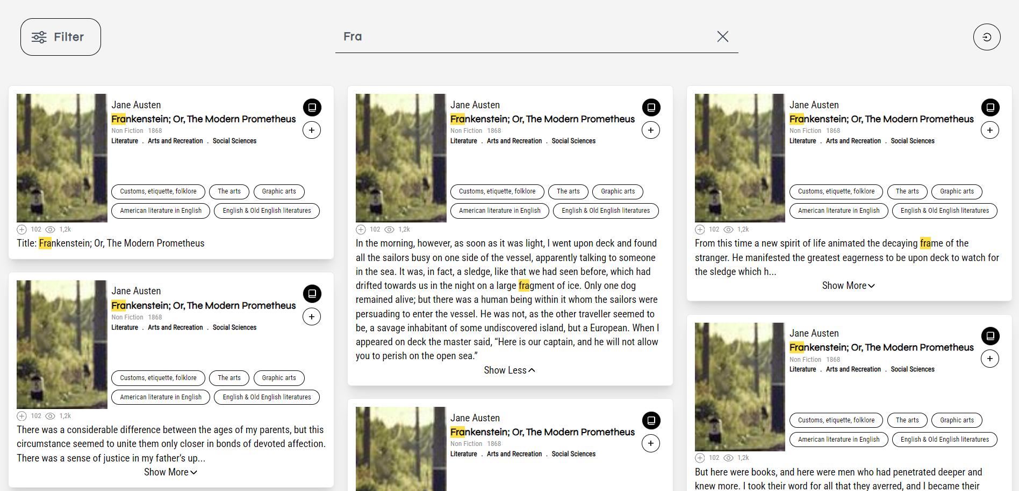

Results are returned as book paragraphs that point to their origin at the source.

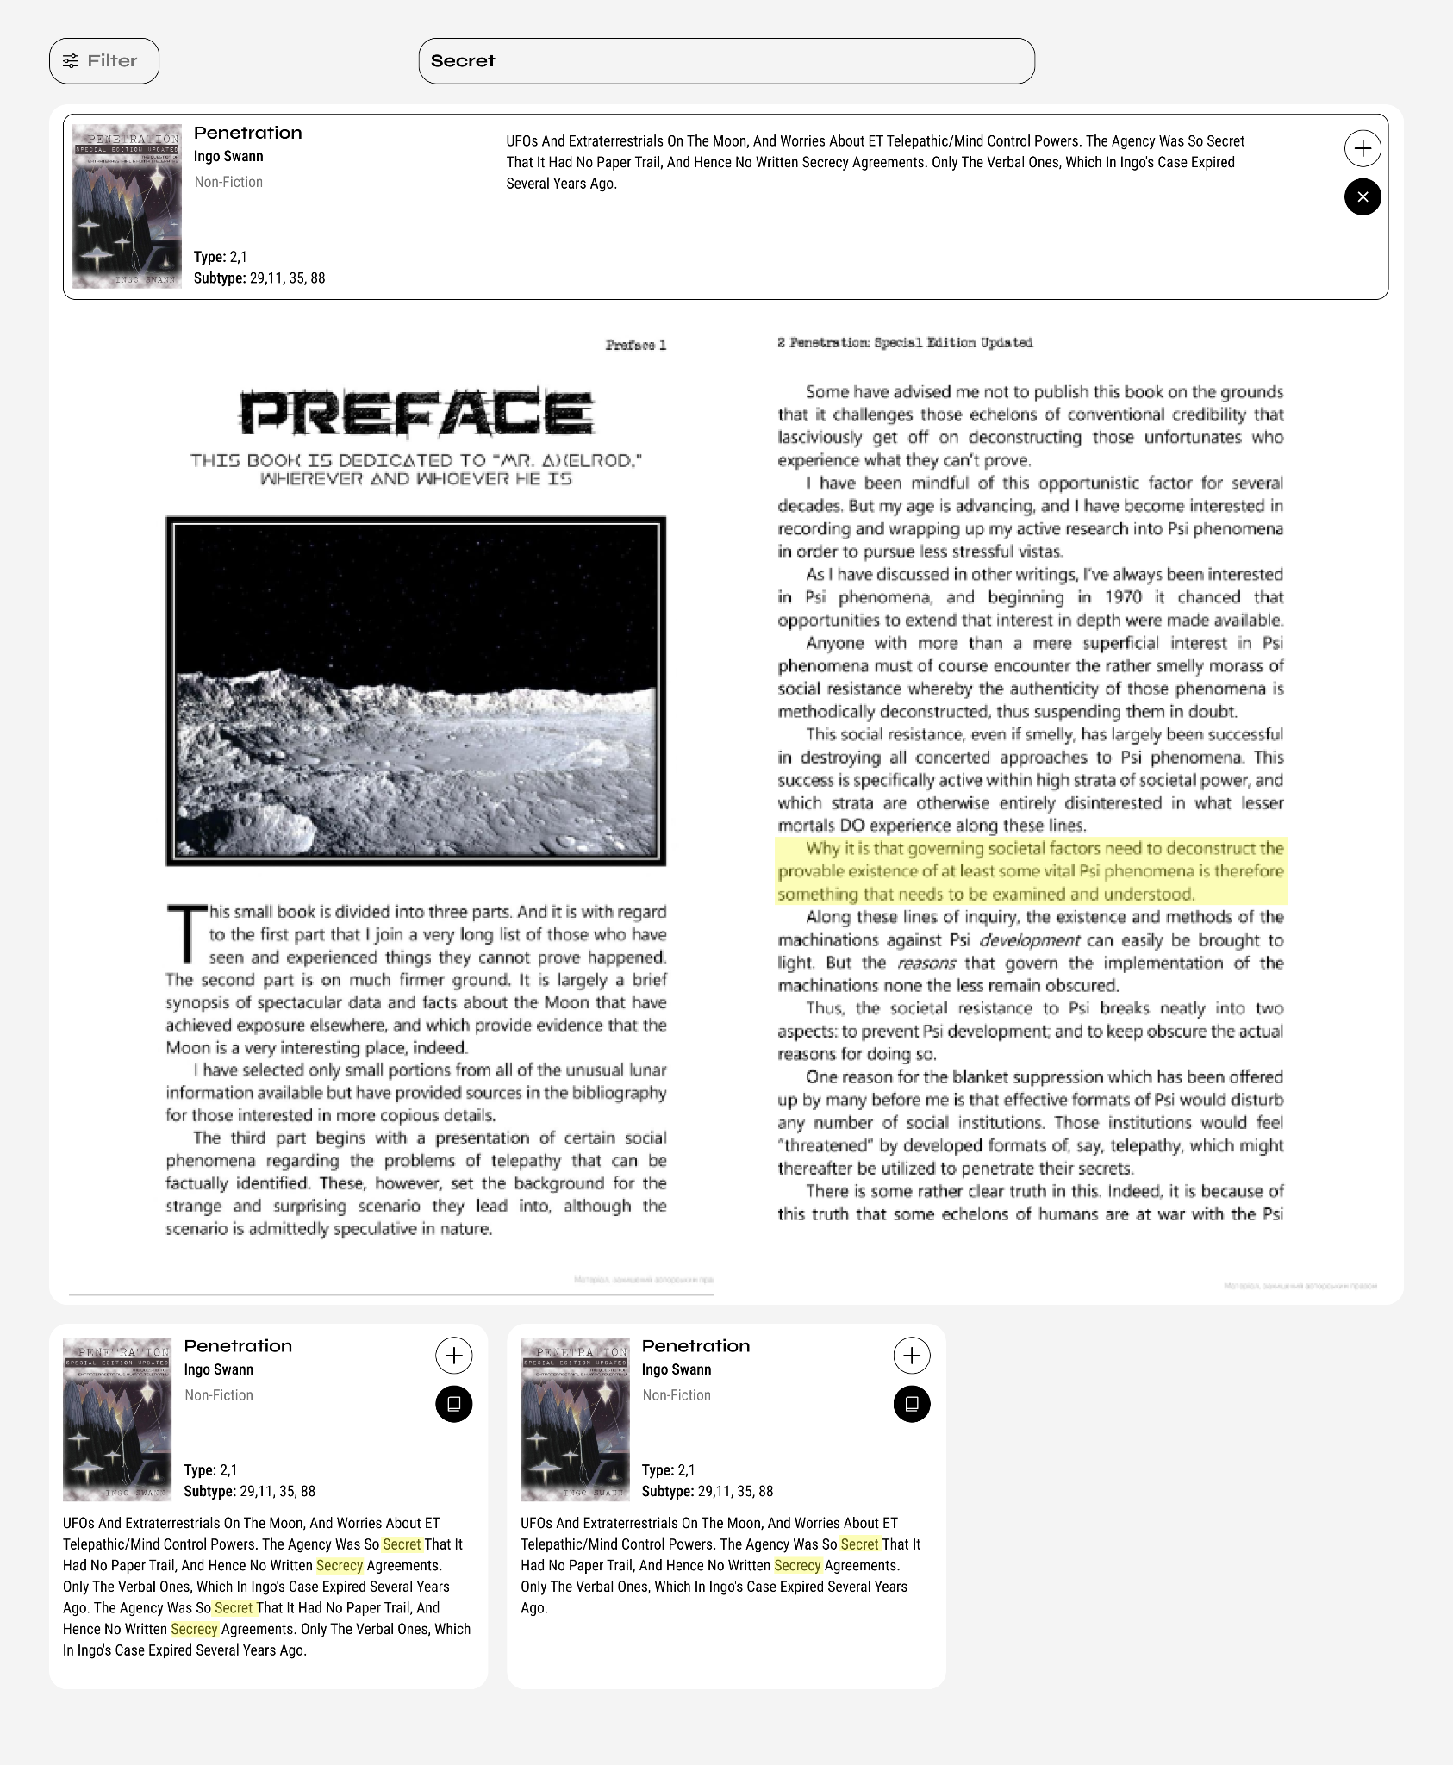

### Read

All search results end in ebooks, making UncensoredGreats akin to Google Search for Kindle—except the search engines are owned by users and all the books are free.

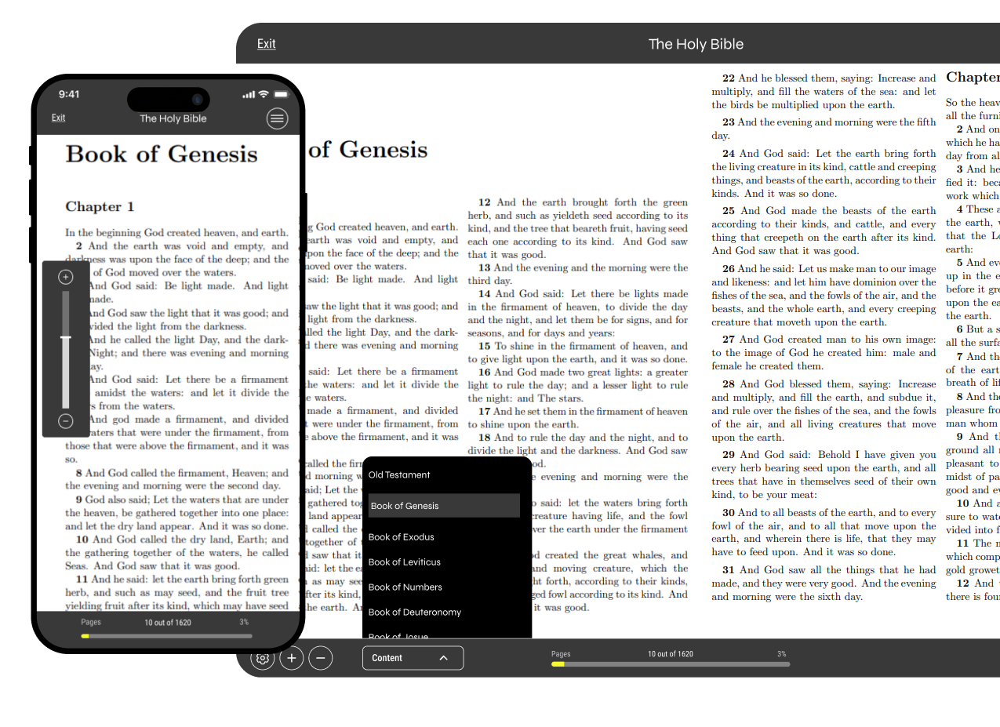

After sign-in and wallet top-up, users mint LBRY for ICP. From there, annotations can be saved as *bookmarks*, shared publicly, and used with AI interactions in exchange for LBRY burn transactions.

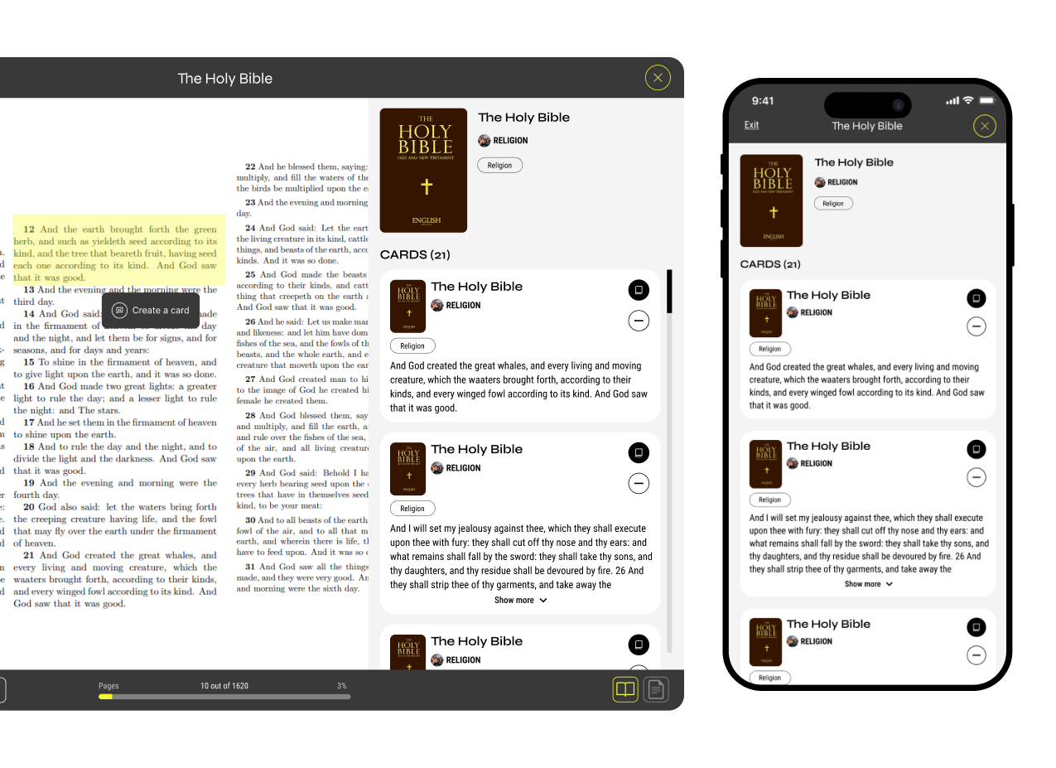

All books used are owned as NFTs. UncensoredGreats does not own or hold them. Rather, *Librarians* (NFT owners) ‘rent’ read access of the .epub file to our canisters, making them free to read and interact with, but impossible to download or otherwise copy.

### Drive

All UncensoredGreats source material is in ebooks (.epub) because it is the superior content medium for high-value information. Storage is 100% on-chain and non-custodial, powered by Web3Disk.

To store ebooks, users become *Librarians* by creating their Web3Disk Asset Canister through the UncensoredGreats Portal, and uploading any books they like.

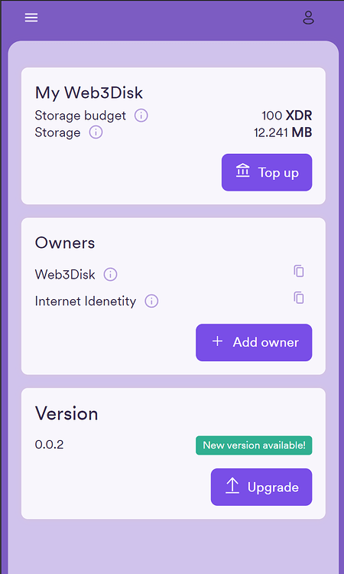

Once connected to their UncensoredGreats Account, these books become generally available in-app. Librarians use these books to produce custom search engines. With a single click, every paragraph in their chosen book(s) is parsed and added as a potential result in their search engine.

Search engines are built with pre-configured Docker Containers (Meilisearch for full-text search and Qdrant for vector search) and deployed via a DAO canister to the Cosmos-based Akash Network. *Librarians* pay the cost of hosting ebook files in their asset canisters and for the search engine hosting in ICP which is fully managed from their UncnesoredGreats Portal.

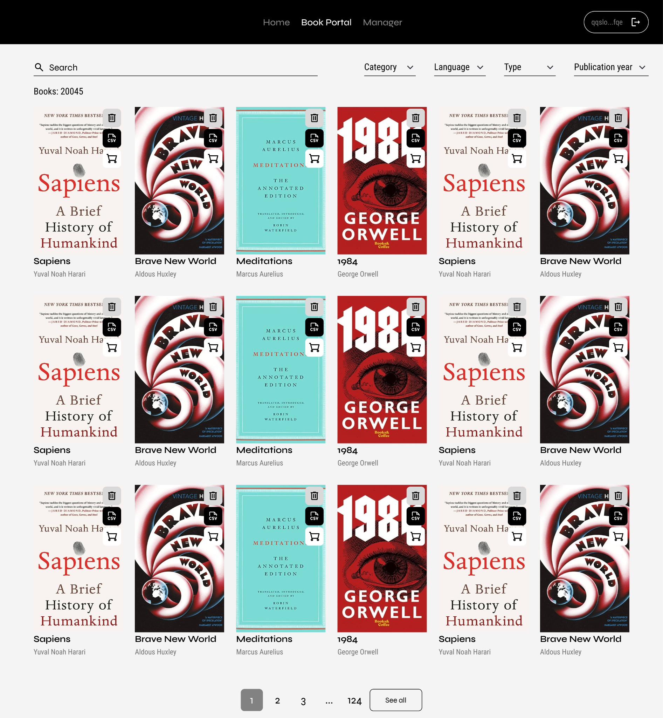

This ownership-based canister model allows each party to retain power over the other. *Librarians* are ‘renting’ the ebook file to UncensoredGreats so long as they are happy with how it is used; while UncensoredGreats, much like any ‘tenant’, can leave the property behind (according to a governance model, if the ebook is shown to be corrupted or pirated).

This push-pull relationship between human contributors and DAO canisters is made enforceable with an incentive mechanism with Book NFTs at its core.

### Earn

Most UncensoredGreats revenue comes from ICP used to mint LBRY. That revenue split is tentatively set at a 50/50 between (1) book owners and (2) UCG Stakers minus canister cycles costs. This section concerns only ICP/LBRY flows, while the Tokenomics section alone explains UCG distribution mechanics.

To use paid features in UncensoredGreats, users first top-up with LBRY at a 1 ICP:1000 LBRY Ratio. This 1:1000 LBRY minting rate is fixed in an immutable canister with zero initial allocations. The cost (in LBRY) for different on-site interactions will remain variable for the foreseeable future to counteract ICP’s volatility.

Every paid interaction sends LBRY to a burn address, and credits the responsible book owner, e.g., when a user burns 1 LBRY to bookmark a *Moby Dick* snippet, the owner of the Moby Dick NFT is owed 0.0005 ICP by the UncensoredGreats protocol (half of the cost to mint that LBRY). Librarians can mint and host as many book NFTs as they like, and claim their ICP rewards whenever they choose.

The remaining ICP goes to canister top-ups, and then to UCG stakers. UCG staking grants voting rights, but voting is optional and does not impact rewards. UCG is not used elsewhere in the app and has no function other than ownership, and rev-share.

### Trade

All that fall into the UncensoredGreats collection are of the ICRC-7 standard, and fully mutable by their author with ICRC-37 extensibility. All Ebook NFTs are mintable on-site for a small fee, and tradable in an on-site marketplace for a 5% royalty. All of this revenue goes to UCG stakers.

NFT Mint Numbers, or UGBNs (UncensoredGreats Book Numbers), are consecutive, so the first book minted has a UCBN of #1, the second with #2, and so on. Once these slots are taken, they can never be changed except by the owner; giving a certain novelty status to early minters.

Since NFTs are based on their ebook files, preventative measures are taken to prevent minting duplicate titles, but this still occurs with different book versions/editions. Still, the visibility, and thus value, of any UncensoredGreats NFT, is weighted by the metadata it accrues from other’s use of it. In other words, readers only need one *Moby Dick*, and the site is designed such that once the first or most used one becomes the crowd favorite, it becomes unprofitable to continue hosting a duplicate.

All data attributed to each Book NFT is listed as follows:

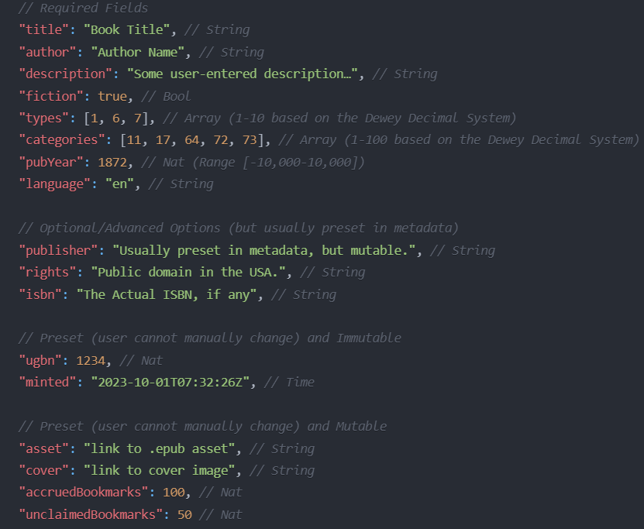

### Aggregate

With the ebook hosting handled with Drive, and file access handled by NFTs; aggregating that ebook data becomes simple.

In the Librarian’s portal, a user can add or remove books from their custom search engine with a single click. When ready, it can be published and public to others, or optionally remain private to the creator.

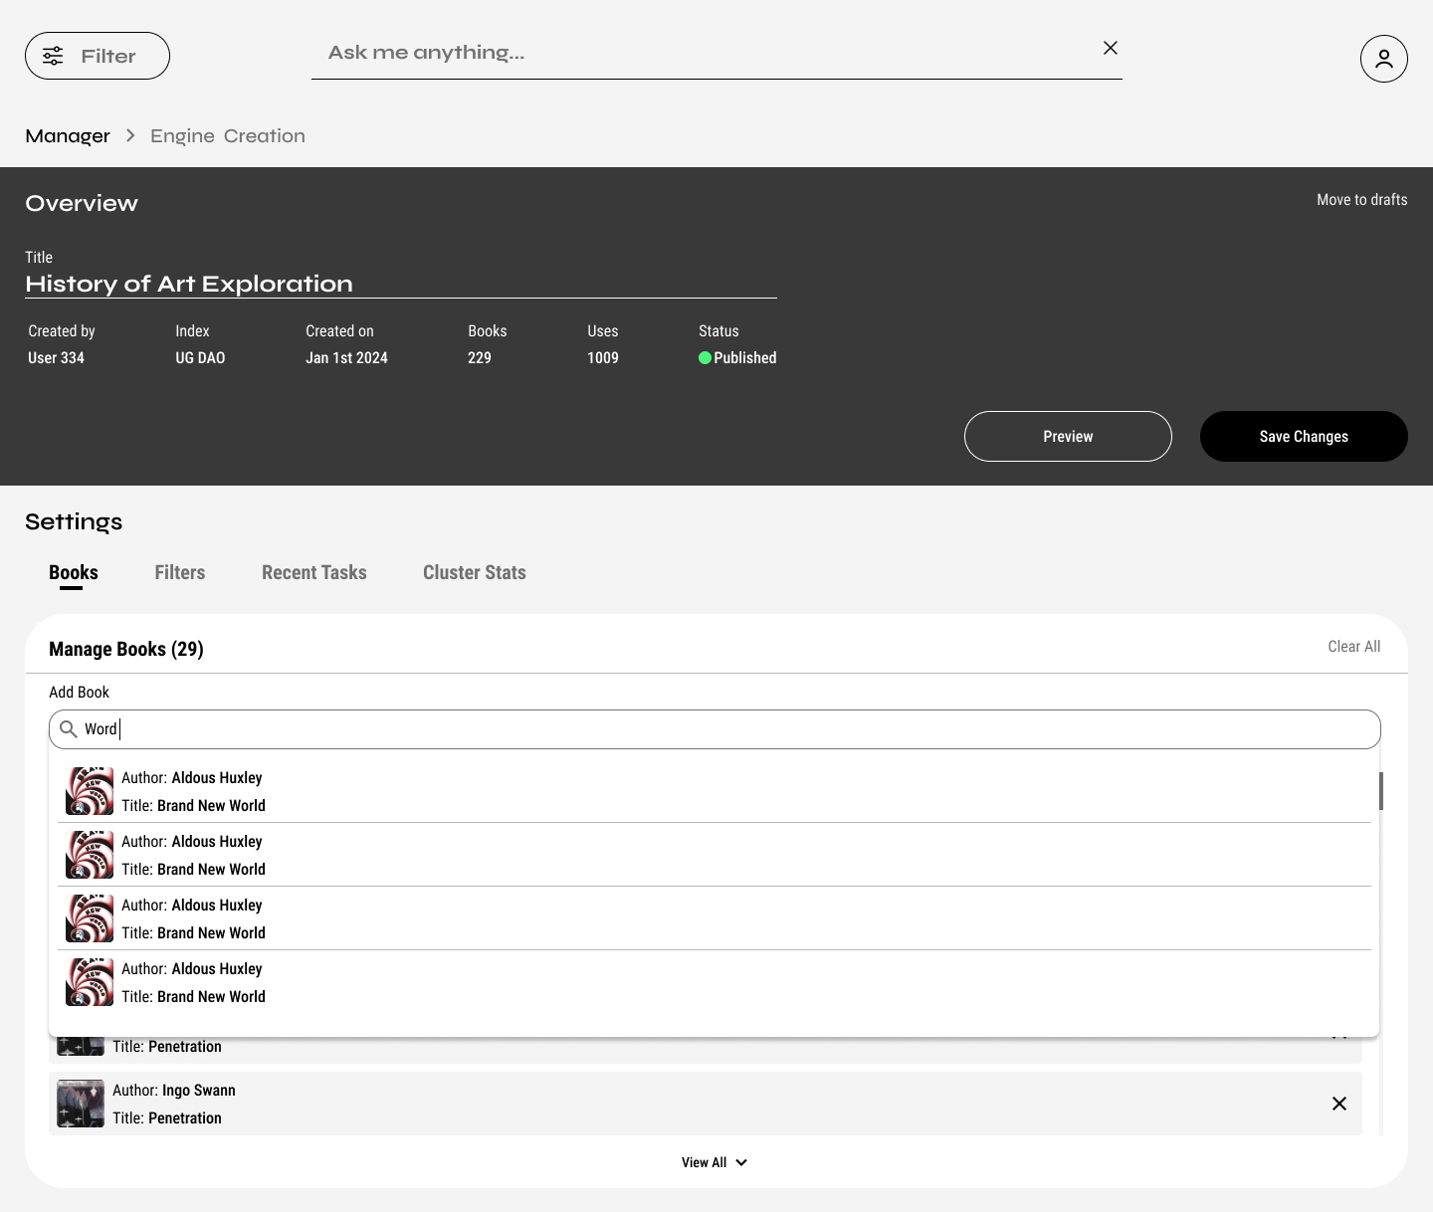

*Librarians* pay for their search engine hosting in ICP via the portal, and receive no direct reward for making the search engine. The incentive for hosting a search engine is that it gives visibility to the books it holds, indirectly generating revenue for those book owners.

### Share

*Bookmarks* are customizable annotations that allow you to save any snippet from any book. What’s left are building blocks of knowledge that someone deemed valuable, and UncensoredGreats simply adds the tools to make it easy to gear them toward answering a question people want the answer to.

*Bookmarks* are pseudonymously public, once saved, so anyone can read and use those snippets. So in addition to full-text search on books, users can search the database of existing bookmarks by book(s). Each subsequent *favorite* of that bookmark rewards UCG the original owner.

### Create

Using bookmarks as a building block, users aggregate and arrange them in combinations for use with AI. An ever-growing suite of on-chain AI tools can be used to summarize, condense, and analyze the perspectives of different authors in relationship to the user’s question.

Such findings are designed to be saved and published to *Whiteboards*: A user-owned virtual space that can be either public or private, that aggregates *Boomarks* with AI outputs and reader notes.

*Whiteboards* are intended to be a Single Source of Truth in the most literal sense. Whether for personal exploration or as the research foundation for a virtual presentation, there is no more comprehensive way to present a case built upon primary sources.

### Internet of Books

Ebooks, like all websites, are HTML pages. We commonly use .epub files with text alone, since they emulate books, but they can just as easily contain images, audio, video, etc. The .epub format shines over .html in organization and information density since their maker must order pages in a linear thread around a coherent subject or idea.

From stone tablets to scrolls, to the codex; books have always been the universal means through which mankind preserves the written and spoken word. Webpages come and go, but for the ones that matter most, UncensoredGreats hopes to be the publisher to bring the modern equivalent to a format of comparable permanence.

In an upcoming iteration, UncensoredGreats will add a bookmaker toolkit, where by YouTube Channels, Podcast RSS feeds, Social Profiles, etc., can be autonomously transcribed and formatted into Ebook NFTs; keeping the same searchability as raw text and the same ease of viewing as their native content platform.

### Tokenomics

UCG is the native token, and will mirror the distribution mechanism of Bitcoin:

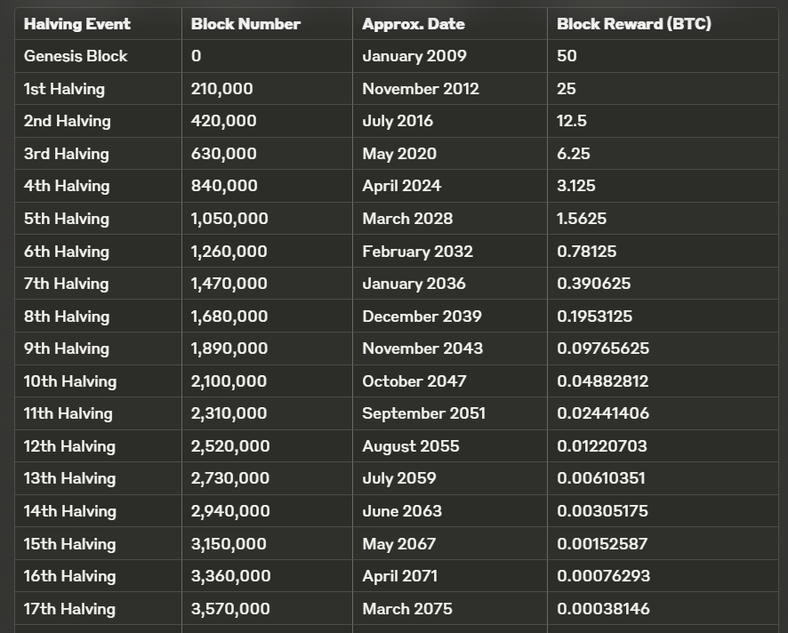

Instead of block mining though, UCG emits based on *favorites*. As a user spends/burns LBRY to save bookmarks, their *favorite* action becomes value-bearing. Users can favorite their own bookmarks, or the bookmarks of others, with caps and mechanisms to prevent bots.

UCG can be added to the staking pool to passively earn a share of UncensoredGreats revenue. Staked UCG also grants optional voting rights, but participation does not impact rewards. UCG does not have any other utility or function.

### Governance

UncensensoredGreats is currently a centrally developed and deployed project. It depends on an architecture of tentatively ‘blackholed’ canisters, so the renounching storage and token related smart contract over time. It is fully open-source, so the current state of decentralizion can be tracked on [Github](https://github.com/UncensoredGreats/).

The frontend will be continuously developed, and so use of backend functions from blackholed canisters will remain mutable indefinitely. Nonetheless, anyone can fork the project with an alternative frontend that’s bound by the same code and data of UncensoredGreats’ universal backend canisters.

Since this model prioritizes immutability for the sake of permanence, governance is limited to matters involving NFT ownership. The governance mechanism allow proposals that can delete NFTs (if corrupted/inaccurate), or transfer the ownership (to any true author that claim it) with a simple majority and quorum of staked UCG holders.